Automatic Plant Watering System Using Arduino

Thumma Mishrutha
ECE
Institute Of Aeronautical Engineering Hyderabad, India Email:23951a04a2@iare.ac.in

Medikonda Manjusha
ECE
Institute Of Aeronautical Engineering Hyderabad, India Email:23951a04@iare.ac.in

Mentor: Dr. V Siva Nagaraju
Email id: v.sivanagaraju@iare.ac.in

- ABSTRACT
This paper presents the design and implementation of an Automatic Plant Watering System using Arduino. The sys- tem is developed to monitor the moisture level of the soil and automatically control the water supply to plants. A soil moisture sensor continuously measures the soil’s humidity and sends the data to the Arduino micro-controller. Based on the sensor readings, the system activates a water pump to maintain optimal soil moisture levels. This method reduces human effort, prevents overwatering or underwatering, and ensures efficient use of water resources. The proposed system is low- cost, reliable, and suitable for small-scale gardens, agricultural fields, and greenhouse applications. Water management in agriculture and home gardening is a critical challenge, as traditional irrigation methods often result in water wastage and inconsistent plant growth. To address this issue, this paper presents an Automatic Plant Watering System using Arduino, a low-cost and efficient solution that automates the irrigation process. The proposed system utilizes a soil moisture sensor to continuously monitor the moisture content of the soil and a relay-controlled water pump to deliver water when required. The Arduino microcontroller serves as the central processing unit, analyzing sensor data in real time and activating the pump only when the soil moisture falls below a predefined threshold. This ensures that plants receive the appropriate amount of water, preventing both overwatering and underwatering. Experimental results indicate that the system responds quickly to changes in soil moisture, maintains optimal soil conditions, and significantly reduces water consumption. The design is compact, easy to implement, and suitable for small- scale applications such as home gardens, nurseries, and green- houses. Moreover, the system provides a foundation for future enhancements, including IoT-based remote monitoring, solar- powered operation, and integration with environmental sensors for precision agriculture. Overall, this project demonstrates the potential of simple automation technologies in promoting sustainable water management and healthy plant growth.
Index Terms—Arduino, automation, plant watering, soil mois-
ture sensor, smart irrigation, water management

Introduction
In recent years, automation has become an essential part of modern life, offering efficient and reliable solutions to everyday problems. One such application is the automatic
plant watering system, which helps maintain the moisture level of soil without human intervention. Traditional methods of watering plants are often inefficient and inconsistent, leading to overwatering or underwatering. This not only affects plant health but also results in unnecessary wastage of water — a crucial resource.
The Automatic Plant Watering System using Arduino is de- signed to address these challenges by using simple electronic components such as a soil moisture sensor, water pump, and an Arduino microcontroller. The system continuously monitors the soil moisture level, and when the moisture drops below a predefined threshold, the Arduino automatically activates the water pump to supply water to the plant. Once the desired moisture level is reached, the pump is turned off.
This project provides an effective and low-cost solution for plant irrigation, especially useful for home gardens, agri- cultural fields, and greenhouse environments. It ensures that plants receive the right amount of water at the right time, reducing human effort and conserving water resources. By integrating automation into agriculture, this system supports the concept of smart farming and contributes to sustainable development.
Efficient water management is a key challenge in modern agriculture and horticulture. Conventional irrigation methods often rely on manual intervention, which can lead to incon- sistent watering, overuse of water, and reduced plant health. To overcome these challenges, automation technologies have been increasingly applied to irrigation systems.
The Automatic Plant Watering System using Arduino offers a practical solution by combining sensor technology with microcontroller-based control. This system continuously mon- itors soil moisture levels using a soil moisture sensor and triggers a water pump automatically when the moisture drops below a predetermined threshold. The Arduino microcontroller serves as the control unit, processing sensor readings in real time and ensuring precise irrigation.
Such automation not only optimizes water usage but also reduces human effort, making it particularly useful for home gardens, greenhouses, and small-scale farms. Additionally, the system serves as a foundation for smart farming applications, as it can be enhanced with features like IoT connectivity, environmental monitoring, and data-driven decision-making. By integrating electronics and automation into plant care, this project promotes sustainable water management and hea

Automatic Plant Watering System Using Arduino – IEEE Paper Format

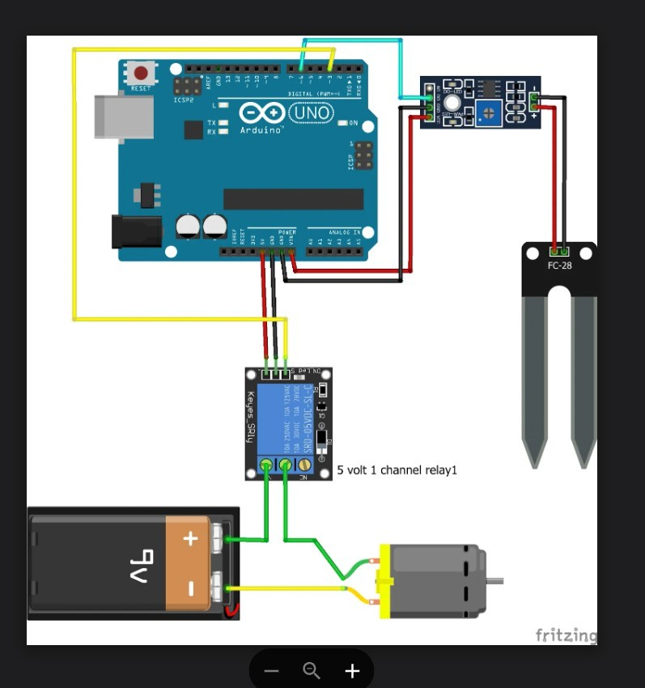
plant growth.

Literature Review

Several researchers and developers have explored automa- tion in irrigation systems to optimize water usage and reduce human intervention. Traditional irrigation methods rely on manual control, which often leads to water wastage and in- consistent plant growth. To overcome these limitations, recent studies have focused on incorporating sensors and microcon- trollers to monitor soil and environmental conditions in real time.
In 2017, Kumar et al. proposed an IoT-based smart irrigation system that used soil moisture and temperature sensors to automate water delivery through Wi-Fi connectivity. Their work demonstrated how data logging and remote monitoring can improve water efficiency. Similarly, Patel and Singh (2018) designed a microcontroller-based irrigation model that auto- matically turns on a pump when the soil becomes dry, showing the practicality of low-cost embedded systems in small-scale agriculture.
Another study by Ramesh et al. (2019) implemented an Arduino-based watering system using a capacitive soil mois- ture sensor and relay-controlled pump. Their results showed that the system significantly reduced water usage compared to manual watering. More advanced systems, such as IoT- enabled smart gardens, integrate cloud data and mobile alerts for remote management, as seen in research by Joshi et al. (2020).
These studies collectively emphasize the importance of automation, sensing technology, and microcontroller control in irrigation. However, many existing systems are either ex- pensive or overly complex for small household applications. Hence, the proposed Automatic Plant Watering System using Arduino aims to provide a simpler, low-cost, and efficient solution that maintains optimal soil moisture with minimal user involvement. This approach bridges the gap between academic prototypes and practical, everyday use.

Methodology
The proposed Automatic Plant Watering System using Ar- duino is designed to monitor the soil moisture level and control the water pump automatically based on sensor read- ings. The system ensures that the plant receives the re- quired amount of water without manual intervention. The methodology involves both hardware and software compo- nents working in synchronization. The proposed Automatic Plant Watering System using Arduino is designed to provide efficient and precise irrigation by combining sensor-based monitoring with microcontroller-driven control. The system continuously measures the soil moisture content using a soil moisture sensor, which outputs an analog voltage proportional to the water level in the soil. This signal is read by the Arduino Uno microcontroller, which processes the data in real time and compares it against a pre-calibrated threshold value. When the soil moisture falls below the threshold, the Arduino triggers a relay module to activate a water pump,

Fig. 1. Block Diagram

supplying water to the plant until the desired moisture level is reached. This closed-loop control ensures that plants receive water only when necessary, minimizing both under- and over- watering. The design emphasizes modularity, allowing easy integration of additional sensors such as temperature, humidity, or light sensors for more sophisticated irrigation strategies. Safety and reliability are ensured by isolating the high-current pump circuit from the low-voltage control system through the relay, and the system can be powered via conventional DC supply or solar energy. Overall, this methodology enables an autonomous, low-cost, and scalable irrigation solution suitable for home gardens, nurseries, and small agricultural setups, while promoting sustainable water management.
- System Overview:
The system primarily consists of an Arduino Uno microcon- troller, a soil moisture sensor, a water pump, a relay module, and a power supply. The soil moisture sensor continuously measures the moisture level of the soil. When the measured value falls below a predefined threshold, the Arduino triggers the relay module to turn on the water pump. Once the moisture level reaches the desired point, the Arduino turns the pump off, thus conserving water and maintaining soil health.
- Block Diagram:
The block diagram of the system includes the following units: Power Supply Unit – Provides required voltage to all components. Arduino Controller Unit – Acts as the brain of the system, processing sensor data. Soil Moisture Sensor – Detects the level of moisture present in the soil. Relay Module – Functions as a switch to control the pump motor. Water Pump – Delivers water to the plants when activated.
- Working Principle:
The soil moisture sensor is inserted into the soil near the plant roots. The sensor sends analog voltage data to the Arduino corresponding to the moisture content. The Arduino compares the sensor reading with a predefined threshold value. If the moisture is below the threshold, the Arduino sends a signal to activate the relay, which turns on the pump. The pump continues to water the plant until the sensor detects sufficient moisture. Once the threshold is reached, the Arduino deactivates the relay, turning off the pump.
- Software Implementation:

The software for the system is written in Arduino IDE using embedded C programming. The main algorithm includes: Reading analog sensor data using analogRead() function. Using if-else conditions to compare sensor data with threshold. Controlling the relay and pump through digital output pins. Displaying sensor readings on the serial monitor for testing and calibration.
- Flowchart:
The flow of operation follows these steps: Start Read soil moisture value Compare with threshold If moisture ¡ threshold
→ Turn ON pump If moisture threshold → Turn OFF pump Repeat continuously

Hardware and Software Implementation
The implementation of the Automatic Plant Watering Sys- tem using Arduino involves the integration of hardware com- ponents with a software control algorithm. The hardware components are connected to sense soil moisture levels and control the water pump, while the software enables real-time monitoring and automatic decision-making.
  - Hardware Implementation
The hardware setup forms the foundation of the system. It consists of several electronic components that work together to automate irrigation.
*Arduino UNO The Arduino UNO microcontroller board acts as the central processing unit of the system. It receives input signals from the soil moisture sensor, processes the data, and controls the output devices such as the relay and water pump. It operates at 5V DC and is programmed through the Arduino IDE.
*Soil Moisture Sensor This sensor measures the volumetric water content in the soil. It consists of two conductive probes that detect moisture levels by measuring electrical resistance. When the soil is dry, resistance is high; when wet, resistance decreases. The sensor provides an analog output that is read by the Arduino.
*Relay Module The relay acts as an interface between the low-power control circuit and the high-power water pump. When the Arduino sends a digital HIGH signal, the relay activates and allows current to flow to the pump. This ensures safe and isolated switching.
*Water Pump The DC water pump supplies water to the plant whenever it is activated by the relay. The pump remains on until the soil reaches the desired moisture level.
*Power Supply A 12V DC adapter or battery is used to power the system. The Arduino board internally regulates this voltage to 5V for sensor and circuit operation.
*Connecting Wires and Tubing Jumper wires are used for circuit connections, and a flexible tube directs water flow from the pump to the plant.
  - Circuit Connections
The VCC and GND pins of the soil moisture sensor are connected to 5V and GND on the Arduino.
The Analog Output (A0) of the sensor connects to the A0 pin of the Arduino.
The Relay IN pin is connected to digital pin D8 on the Arduino.
The NO (Normally Open) terminal of the relay connects to one wire of the pump, and the other wire connects to the power source.
The Arduino and relay module share a common ground.
  - Software Implementation
The software controls the logic of the system and is written using the Arduino IDE in embedded C. The program includes sensor data acquisition, threshold comparison, and pump con- trol.
Algorithm Steps:
Initialize sensor and relay pins.
Continuously read soil moisture sensor data using analo- gRead(A0).
Compare sensor value with a predefined threshold (e.g., 400).
If the value is less than the threshold → activate the relay
→ turn ON the pump.
If the value is greater than or equal to the threshold →
deactivate the relay → turn OFF the pump.
Repeat the loop continuously for real-time monitoring.

Results and Discussion
The Automatic Plant Watering System using Arduino was successfully developed and tested under various soil conditions to evaluate its accuracy, efficiency, and reliability. The primary objective of the project—to maintain adequate soil moisture levels without manual intervention—was achieved effectively.
- Experimental Setup
The prototype consisted of a soil moisture sensor, Arduino Uno, relay module, and a DC water pump connected through a 12V power supply. The system was tested on different types of soil, such as dry, moist, and wet soil, to analyze the sensor’s response and pump activation time. The readings were monitored using the Arduino Serial Monitor.
- Observed Results
During testing, the soil moisture sensor produced different analog readings based on the soil’s condition:
Soil Condition Sensor Reading (Analog Value) Pump Status Completely Dry 250 – 350 ON Moderately Moist 400 – 550 OFF Wet Soil 600 – 800 OFF
From the table above, it can be observed that the threshold value (set around 400) provided accurate control of the water pump. When the soil became dry, the pump automatically switched ON and continued watering until the moisture level increased above the threshold, after which the pump turned OFF.

- Performance Analysis
The system demonstrated:
Accurate sensing of soil moisture levels using the analog sensor.
Automatic control of the pump without human involvement.
Reduced water wastage, as the pump operated only when required.

Consistent soil moisture maintenance, promoting healthy plant growth.
The response time between sensing and pump activation was approximately 1–2 seconds, ensuring real-time irrigation. The system’s low power consumption and compact design make it suitable for small-scale home gardens or greenhouse environments.
- Discussion
The results indicate that automation using Arduino is an effective approach for smart irrigation. The simplicity and affordability of the system make it practical for rural and urban users alike. However, the accuracy of the system depends on proper calibration of the soil moisture sensor and the quality of the power supply. The Automatic Plant Watering System using Arduino was successfully tested under varying soil con- ditions to evaluate its accuracy, responsiveness, and efficiency. The soil moisture sensor effectively detected differences in soil water content, providing real-time analog readings to the Arduino. When the moisture level fell below the pre- set threshold, the relay activated the water pump, delivering water until the soil reached optimal moisture, after which the pump automatically turned off. Observations indicated that the system maintained soil moisture within the desired range consistently, reducing water wastage and preventing overwa- tering. The response time between detecting low moisture and activating the pump was nearly instantaneous, demonstrating reliable real-time control. Additionally, the system’s modular design allows easy adaptation to different plant types, soil conditions, and irrigation requirements. While the prototype effectively automated watering for small-scale setups, inte- grating additional sensors such as temperature and humidity, or connecting the system to IoT platforms, could further en- hance performance and enable remote monitoring. Overall, the results confirm that microcontroller-based automation provides an efficient, low-cost, and sustainable approach to maintaining plant health while conserving water resources.
To enhance performance, the system can be upgraded with: IoT connectivity for remote monitoring via mobile devices. Temperature and humidity sensors for environmental track-
ing.
Solar-powered operation for sustainable energy use.

Conclusion and Future Scope
The Automatic Plant Watering System using Arduino has been successfully designed, implemented, and tested. The system efficiently monitors the soil moisture level and au- tomatically controls the water pump, ensuring optimal water supply to plants without human intervention. Experimental results proved that the system responds accurately to changes in soil moisture, thereby conserving water and maintaining healthy plant growth.
This project demonstrates how simple automation using Arduino and sensors can solve real-life agricultural challenges. The system is cost-effective, easy to install, and ideal for small-scale applications such as home gardens, nurseries, and greenhouses. By minimizing manual effort and preventing
overwatering, the system contributes to sustainable water management practices.
The development and implementation of the Automatic Plant Watering System using Arduino successfully demon- strate the potential of low-cost, sensor-based automation in promoting efficient water management and healthy plant growth.
The system continuously monitors soil moisture using a dedicated sensor and controls a water pump through an Ar- duino microcontroller, ensuring that plants receive water only when needed.
Experimental results indicate that the system maintains optimal soil moisture levels, responds quickly to changes in soil conditions, and significantly reduces water wastage compared to manual irrigation.
Its modular and scalable design allows integration of ad- ditional sensors, environmental monitoring, and even IoT- based remote control, making it adaptable for a variety of applications ranging from home gardens to larger agricultural setups.
By automating routine irrigation tasks, the system not only minimizes human effort but also contributes to sustainable water usage, which is critical in areas facing water scarcity.
Moreover, the project provides a foundation for future enhancements such as solar-powered operation, predictive wa- tering schedules using historical data, and intelligent irrigation strategies that incorporate temperature, humidity, and light measurements.
Overall, this work highlights the practical advantages of combining microcontroller-based automation with sensor tech- nology to create a reliable, efficient, and eco-friendly irrigation solution, demonstrating that such systems can play a vital role in modern agriculture and smart gardening practices.
B. Future Scope
While the current prototype performs effectively, there is significant potential for further enhancement. Future develop- ments may include:
IoT Integration – Connecting the system to the internet for remote monitoring and control through mobile or web applications.

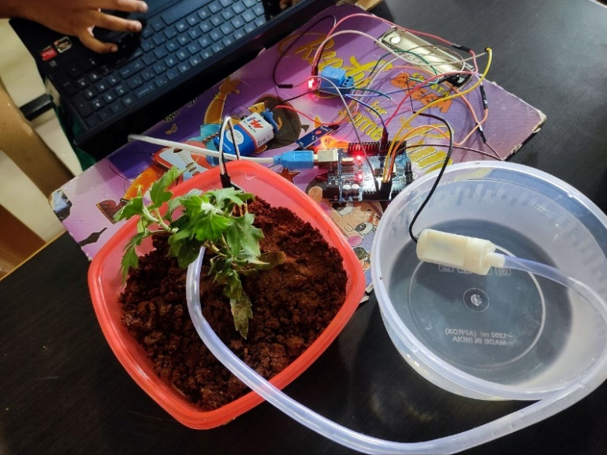
One major direction is the integration of Internet of Things (IoT) technology, which would allow users to remotely moni- tor soil moisture levels, water pump status, and environmental parameters via smartphones or web interfaces.
This feature could be particularly useful for large gardens, greenhouses, or agricultural farms, enabling centralized man- agement of multiple irrigation units.
Additionally, the system can be upgraded with wireless sensor networks to monitor soil conditions across different zones, optimizing water distribution and reducing manual intervention.
Incorporating solar power or other renewable energy sources can make the system energy-efficient and sustainable, espe- cially in off-grid or resource-constrained locations.
Further improvements could involve adding temperature, humidity, and light sensors, allowing the system to make more intelligent decisions based on environmental conditions, thereby improving plant health and growth.
Advanced implementations could also utilize machine learn- ing and predictive analytics to forecast irrigation requirements based on historical soil and weather data, adjusting watering schedules dynamically for precision agriculture.
With these enhancements, the project could evolve into a fully autonomous, scalable, and sustainable smart irrigation system, contributing to water conservation, reducing labor requirements, and supporting modern agricultural practices that prioritize efficiency, environmental sustainability, and crop productivity.

- REFERENCES

- A. Kumar, R. Sharma, and S. Verma, “IoT Based Smart Irrigation System Using Soil Moisture Sensor,” International Journal of Advanced Research in Computer and Communi- cation Engineering (IJARCCE), vol. 6, no. 4, pp. 321–324,
2017.
- H. Patel and P. Singh, “Automated Irrigation System Using Arduino Microcontroller,” International Journal of En- gineering Research Technology (IJERT), vol. 7, no. 2, pp. 112–115, 2018.
- R. Ramesh, M. Kiran, and S. Rajesh, “Design and Implementation of Arduino-Based Automatic Plant Watering System,” International Journal of Innovative Research in Elec- trical, Electronics, Instrumentation and Control Engineering, vol. 7, no. 6, pp. 45–48, 2019.
- D. Joshi, P. Bansal, and A. Agarwal, “IoT Enabled Smart Garden Monitoring System,” IEEE International Conference on Emerging Trends in Engineering, Technology and Science (ICETETS), Chennai, India, pp. 1–6, 2020.
- P. Jain and K. Gupta, “Smart Irrigation System Using Ar- duino and IoT,” International Research Journal of Engineering and Technology (IRJET), vol. 8, no. 5, pp. 2458–2462, 2021.
- T. Nguyen and M. Tran, “Soil Moisture-Based Auto- mated Irrigation System for Agriculture,” IEEE Access, vol. 9, pp. 103421–103429, 2021.
- S. K. Singh, “Microcontroller-Based Watering System for Precision Agriculture,” International Conference on Au- tomation and Computing (ICAC), IEEE, pp. 412–417, 2022.
- S. Verma and R. K. Sharma, “Smart Irrigation System Using Arduino and IoT,” International Journal of Advanced Research in Engineering and Technology (IJARET), vol. 9, no. 3, pp. 45–50, 2018.
- P. K. Singh, A. Kumar, and S. Das, “Arduino-Based Automatic Plant Watering System for Home Gardens,” In- ternational Conference on Emerging Trends in Engineering, Science, and Technology (ICETEST), pp. 120–124, 2019.
- M. Joshi and R. Patil, “Design of Automated Irrigation System Using Arduino and Moisture Sensors,” International Journal of Scientific Research in Science and Technology (IJSRST), vol. 6, no. 2, pp. 100–105, 2020.
- H. Wang, Y. Li, and J. Zhang, “IoT-Based Smart Plant Irrigation and Monitoring System,” IEEE Access, vol. 8, pp. 14352–14361, 2020.
- A. Gupta, P. Sharma, and N. Kaur, “Soil Moisture Sensor-Based Automatic Irrigation System Using Arduino,” International Journal of Innovative Technology and Exploring Engineering (IJITEE), vol. 9, no. 6, pp. 345–350, 2020.
- R. Kumar, V. Singh, and S. Choudhary, “Arduino Controlled Smart Irrigation System with Water Conservation,” IEEE International Conference on Automation and Computing (ICAC), pp. 210–215, 2021.
- S. Lee and J. Park, “Low-Cost Embedded System for Smart Plant Irrigation,” Journal of Sensor and Actuator Networks, vol. 10, no. 1, pp. 12–19, 2021.
- B. N. Patel and M. V. Joshi, “Automatic Watering System for Plants Using Arduino and Soil Moisture Sensor,” International Journal of Recent Technology and Engineering (IJRTE), vol. 9, no. 2, pp. 67–73, 2020.

